The CodeRoom (Pty) Ltd.

Aftas’Cool MVP

Scope Document Ver 1.0





Version 1.1 - May 2015

[www.thecoderoom.co.za](http://www.thecoderoom.co.za) Centurion | Durban | Cape Town

083 238 9828

[greg@thecoderoom.co.za](mailto:greg@thecoderoom.co.za)

[@thecoderoom](mailto:@thecoderoom) pages/CodeRoom

# Revision & Sign-off Sheet

**Document Properties**

|  |  |
| --- | --- |
| **Item** | **Details** |
| Document Title | AftasCool MVP Scope Ver 1.0 |
| Author | Greg Fibiger |
| Creation Date | 2015/06/10 |

Versions

|  |  |  |  |
| --- | --- | --- | --- |
| **Version** | **Revision** | **Resource** | **Date** |
| 1.0 | MVP Scope | Greg Fibiger | 2015-06-21 |
| 1.1 | Moderator/Architect | Willie Burger |  |
| 1.2 | Scope | Development Team |  |

# Table of Contents

Revision & Sign-off Sheet 2

Table of Contents 3

Overview 5

Glossary of Terms 5

Definitions 5

**MVP Solution Development Criteria and Guidelines** 6

***(Discussed with AftasCool)*** 6

**The CodeRoom MVP Solution Development Process** 7

***(Discussed with AftasCool)*** 7

Business Requirements 8

REQUIREMENT / OPPORTUNITY STATEMENT 8

Scope 8

Assumptions 9

Exclusions 9

Functional Requirements (Part 1) 10

**(Talent Asses Video Upload – TAVU)** 10

Requirements and Business Rules (Windows Phone Application) 10

USAGE REQUIREMENTS/SCENARIOS 11

**(Talent Asses Video Upload – TAVU)** 11

Usage Scenarios 11

UC 1.0 11

UC 1.1 12

UC 1.2 13

UC 1.3 14

UC 1.4 15

Functional Requirements (Part 2) 16

**(Talent Credit Assessment – TCA)** 16

Requirements and Business Rules – Web Application 16

USAGE REQUIREMENTS/SCENARIOS 17

**(Talent Credit Assessment – TCA)** 17

Usage Scenarios 17

UC 2.0 17

UC 2.1 18

UC 2.2 19

UC 2.3 20

UC 2.4 21

UC 2.5 21

Non-Functional Requirements 22

Usability 22

Reliability and Performance 22

Support and Maintenance 22

Capacity 22

Exclusions 22

# Overview

This document details the Scope before we produce the Functional Specification Requirements (FSR) for the AftasCool MVP (Minimal Viable Product)

This document also includes high level details of integration and functionality requirements. It will serve to clearly define the scope of the full implementation.

**Partner:** AftasCool **Date**: 2015-06-12

**BizSpark Portfolio Manager:** Phia Van der Spuy (phiavds@me.com)

**Venue:** Skukuza Meeting Room (MSFT) Bryanston **Architect**: Willie Burger/Greg Fibiger

**Partner Attendee/s:** Sydney Mokgoatsane (email: seedny@gmail.com)

**Contact Person:** Sydney Mokgoatsane **Contact Number**: 0798487048

# Glossary of Terms

|  |  |
| --- | --- |
| **Term** | **Description** |
| TCR | The Code Room |
| SDLC | Software Development Life Cycle |
| MVP | Minimal Viable Product/Part |
| TAVU | Talent Asses Video Upload |
| TCA | Talent Credit Assessment |

# Definitions

|  |  |
| --- | --- |
| **Definition** | **Description** |
| Minimal Viable Product/Part | The smallest part of a system that can be produced in the allowed time/budget that will produce certain business value. |

## **MVP Solution Development Criteria and Guidelines**

## ***(Discussed with AftasCool)***

1. The purpose of a MVP (Minimal Viable Product) is to provide AftasCool with a provable & demonstrable solution in a rapid development lifecycle that will support & validate their Business Case/value offering to potential or existing clients. Funding for subsequent software development (beyond the scope of the MVP) is the responsibility of AftasCool

*Note: An MVP by “de facto” is NOT a complete solution and is normally a 3 – 4 week vigorous & robust development Project*

1. AftasCool MUST be a registered BizSpark member (i.e. have access to the numerous benefits of the programme) and have a Windows Azure Account
2. The AftasCool MVP Solution development ONLY developed through Microsoft Technologies.

*Note: There could be collaboration with other technologies, languages and services BUT will not be included within a MVP*

1. The assumption is that all professional business ability assessments, market research, SWOT analyses, business plans etc. MUST have been completed within the BizSpark ecosystem (portfolio managers & mentors) prior to engaging on MVP development.

*Note: CodeRoom provides the technical augmentation to the Business Case/Value Offering*

1. The AftasCool MVP Solution development focusses on functionality with less emphasise on UX “cosmetics”, graphical bells and whistles. Minimal UX will be provided to make it presentable
2. AftasCool was informed of the licensing and costing of the different Microsoft Services and Cloud based services AND All 3rd party integration that may potentially be part of the solution (outside the scope of the MVP)

## **The CodeRoom MVP Solution Development Process**

## ***(Discussed with AftasCool)***

1. AftasCool BizSpark Portfolio Managers will schedule the MVP Scoping session with CodeRoom Architects AND MUST also attend in order to introduce CodeRoom to the BizSpark Member

*Note: During the MVP scoping sessions not ALL aspects of the BizSpark member Business Cases/Value Offerings needs to be exposed i.e. artefacts, diagrams etc. However – regarding the MVP, ALL the relevant artefacts, documentation and diagrams MUST be provided*

1. CodeRoom discusses the MVP within Architect and Development team AND may provide a MVP Solution feasibility assessment (based on inter alia functionality, time and resources) derived from the Scope meeting. The AftasCool MVP FRS (Functional Requirement Specification) document is then produced
2. The Development of the MVP commences : This includes

* Portal & Bit Bucket Source Code Activation e.g. [http://thecoderoom.dedicated.co.za](http://thecoderoom.dedicated.co.za/)
* MVP Solution Design & Architecture
* MVP Solution Development, Testing & internal releases
* PM and weekly feedback to AftasCool

1. The MVP Handover and sign-off is the final step which includes:

* All relevant MVP Code to AftasCool
* Examples and Wireframes *(where applicable)*
* Knowledge transfer and mentoring (where applicable)
* Signed Off handover document
* ANY Next steps discussions which may include a technical Presentation with AftasCool to potential clients

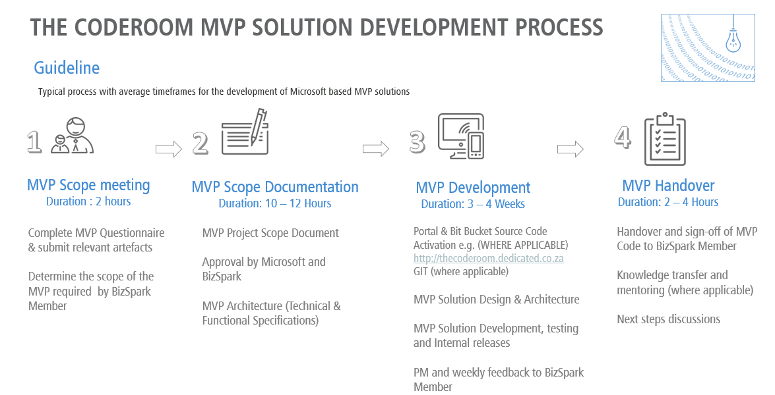

# Business Requirements

## REQUIREMENT / OPPORTUNITY STATEMENT

AftasCool provides an activities platform which makes learning fun AND correlates learning to REAL life. This platform provides a journey of learning, information, creating, chatting, friendship, growth, rewards, career, with tutors, teachers and classmates. Amongst THE numerous platforms and Services we have identified the (2) Minimal Viable Product (MVP)

Objective (aligned to Go to Business Strategy AND value Offering)

1. Pilot the MVP System in certain schools to test validity and functionally of System
2. Present to potential Stakeholders for the purpose of “land and expand” strategies as well as providing a broader AftasCool platform

AftasCool intends to:

* Use a Windows Mobile Application to capture Talent Asset assessment and upload to Azure Cloud for consumption and behavioural Analytics.
* Create a Microsoft ASP.NET web platform to Capture Learner detail, Categorised Questionnaire (assessment) information AND Credit scoring system persisted in a centralised repository (Database)
* Create a Basic Graphical report to monitor the status of a learner during the duration of the AftasCool programme

## Scope

* A Windows Mobile Application to capture Talent Asset Assessment videos (Talent Upload), compress it (limit to 3 min in length) and submit to Azure Cloud. This will include basic Metadata such as Name, School, and Topic etc.
* Basic Web Application (for Consumption and viewing of Asset Videos) based on User details
* Create a Microsoft ASP.NET web platform to Capture Learner detail, Create Categorised Questionnaire (assessment) information AND Credit scoring algorithms persisted within a centralised repository (Database)
* Create a Basic Graphical report to monitor the status of a learner during the duration of the AftasCool programme

## Assumptions

The solution design is based on the following assumptions:

* Data will be available by the required dates.
* Decisions will be made in a timely manner.
* Resources will be made available to the project when required and in a timely manner.

## Exclusions

* Integrations with other systems will be subject to another analysis and design e.g. API to payment gateways
* The Code Room will not be liable for any license fees / costs for any software or services. We will however advise the client on any such costs / fees.

# Functional Requirements (Part 1)

## **(Talent Asses Video Upload – TAVU)**

## Requirements and Business Rules (Windows Phone Application)

The following requirements have been identified for the Solution. **Note**: Numbering is used for traceability and not sequence.

|  |  |  |
| --- | --- | --- |
| Requirement Number | Requirement Name | Use Case Reference |
| Req.1 | **Requirement:**  User must be able to register on the TAVU mobile application  **Business Rule:**  User Registration capability when not registered | UC 1.0 |
| Req.2 | **Requirement**  Secure Log in to TAVU mobile application  **Business Rule:**  Provide Secure Login to Talent Asses Video Upload | UC 1.1 |
| Req.3 | **Requirement:**  TAVU User should be able to enter Metadata (e.g. Category, Type of Video etc.)  **Business Rule:**  The system will provide metadata capturing capabilities to enter all relevant metadata (MVP) | UC 1.2 |
| Req.4 | **Requirement:**  Record TAVU Video  **Business Rule:**  User should be able to take a video from his/her Windows Mobile Phone. Upload Video (30 sec. to 3 min MAX)  The system will provide the capacity to take a video (built in) limited to certain length | UC 1.3 |
| Req.5 | **Requirement:**  TAVU User should be able to save the recording video and upload to a centralised Data repository (Cloud)  **Business Rule:**  The system will provide the capacity to take a video (built in) limited to certain length | UC 1.4 |

# USAGE REQUIREMENTS/SCENARIOS

## **(Talent Asses Video Upload – TAVU)**

## Usage Scenarios

The Usage Scenarios describe the set of activities that the solution will address and support. These activities are described in terms of what the user wants the solution to do and what other interfacing applications and systems need the solution to do. This information is expressed in terms of actions (functions), actors (users in a specific situation), paths (moving from one state to another within a function), conditions (what must occur to move down the path), constraints, business rules and results (output). User Interface mock-up (Where applicable) will also be created for a specific use case.

### UC 1.0

|  |  |  |
| --- | --- | --- |
| Use Case ID: | UC 1.0 | |
| Use Case: | User Register on TAVU | |
| Notes: | User must be able to register on the TAVU application | |
| Type: | Basic Path |  |
| Scenario: | Basic Path |  |
|  | Step | Action |
|  | 1 | User downloads application |
|  | 2 | App displays the page to fill in the information |
|  | 3 | User fills in their information |
|  | 4 | User clicks the submit button |
|  | 5 | System displays pop up ,alerting the user on successful sign-up |
| Type: | Alternate | |
| Scenario: | User enters incorrect information | |
|  | Step |  |
|  | 1 | System displays alerts of null/invalid data entered |

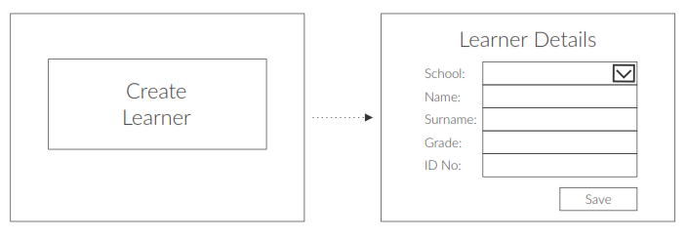

### UC 1.1

|  |  |  |
| --- | --- | --- |
| Use Case ID: | UC 1.1 | |
| Use Case: | Secure Log in to TAVU mobile application | |
| Notes: | User must be able to securely login on the TAVU application | |
| Type: | Basic Path |  |
| Scenario: | Basic Path |  |
|  | Step | Action |
|  | 1 | User enters Username and Password |
|  | 4 | User clicks the submit button |
|  | 5 | System displays pop up ,alerting the user on successful login |
| Type: | Alternate | |
| Scenario: | User enters incorrect information | |
|  | Step |  |
|  | 1 | System displays alerts of null/invalid data entered |

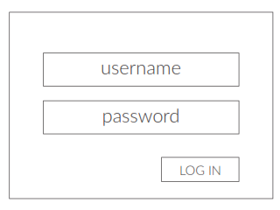

### UC 1.2

|  |  |  |
| --- | --- | --- |
| Use Case ID: | UC 1.2 | |
| Use Case: | TAVU User should be able to enter Metadata (e.g. Category, Type of Video etc.) | |
| Notes: | The system will provide metadata capturing capabilities to enter all relevant metadata (MVP) | |
| Type: | Basic Path |  |
| Scenario: | Basic Path |  |
|  | Step | Action |
|  | 1 | User Completes the Metadata input boxes |
|  | 4 | User clicks the take Video button |
|  | 5 | System displays pop ups on Validations (if applicable) |
| Type: | Alternate | |
| Scenario: | User enters incorrect information | |
|  | Step |  |
|  | 1 | System displays alerts of null/invalid data entered (Validations where applicable) |

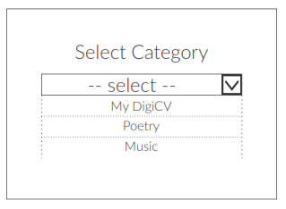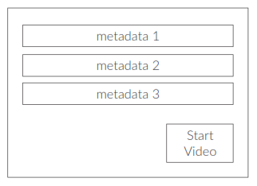

### UC 1.3

|  |  |  |
| --- | --- | --- |
| Use Case ID: | UC 1.3 | |
| Use Case: | Record TAVU Video | |
| Notes: | User should be able to take a video from his/her Windows Mobile Phone. Upload Video (30 sec. to 3 min MAX)  The system will provide the capacity to take a video (built in) limited to certain length | |
| Type: | Basic Path |  |
| Scenario: | Basic Path |  |
|  | Step | Action |
|  | 1 | TAVU user clicks on Record Video |
|  | 2 | Built in Video Camera records the video |
|  | 3 | Cut off after 3 minutes (optional) |
|  | 4 | Recording automatically saved on device |
| Type: | Alternate | |
| Scenario: | User selects “Save Recording” | |
|  | Step |  |
|  | 1 | System saves recording and closes the window. |



### UC 1.4

|  |  |  |
| --- | --- | --- |
| Use Case ID: | UC 1.4 | |
| Use Case: | Save and Persist TAVU Video | |
| Notes: | TAVU User should be able to save the recording video and upload to a centralised Data repository (Cloud) – for assessment | |
| Type: | Basic Path |  |
| Scenario: | Basic Path |  |
|  | Step | Action |
|  | 1 | TAVU user saves video to local device |
|  | 2 | TAVU user can submit the video to centralised repository (Cloud) |
| Type: | Alternate | |
| Scenario: | User selects “Upload Recording” | |
|  | Step |  |
|  | 1 | System sends TAVU recording and closes the window. |

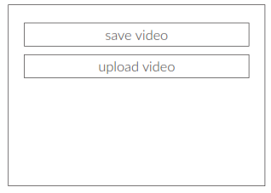

# Functional Requirements (Part 2)

## **(Talent Credit Assessment – TCA)**

## Requirements and Business Rules – Web Application

The following requirements have been identified for the Solution. **Note**: Numbering is used for traceability and not sequence.

|  |  |  |
| --- | --- | --- |
| Requirement Number | Requirement Name | Use Case Reference |
| Req.1 | **Requirement**  Assessor should be able to register on TCA Web Application  **Business Rule:**  Registration capability when not registered | UC 2.0 |
| Req.2 | **Requirement:**  Assessor should be able to LOG IN with either Username/Password OR through Google/Facebook  **Business Rule:**  The TCA system will provide Login capabilities | UC 2.1 |
| Req.3 | **Requirement:**  Assessor needs to create Category (with Questionnaire as next level)  **Business Rule:**  A link to the Category/Questionnaire capture screens is provided on the Landing Page | UC 2.2 |
| Req.4 | **Requirement:**  Talent Credit Assessments completed against learner based on Category  **Business Rule:**  Assessor completes TCA against learner | UC 2.3 |
| Req.5 | **Requirement:**  TCA Information should be saved  **Business Rule:**  Persist information on TCA to Database | UC 2.4 |
| Req.6 | **Requirement:**  In-Flight Report against Learner (TCA)  **Business Rule:**  Provide report capabilities (Part 1) Basic Matrix report | UC 2.5 |

# USAGE REQUIREMENTS/SCENARIOS

## **(Talent Credit Assessment – TCA)**

## Usage Scenarios

The Usage Scenarios describe the set of activities that the solution will address and support. These activities are described in terms of what the user wants the solution to do and what other interfacing applications and systems need the solution to do. This information is expressed in terms of actions (functions), actors (users in a specific situation), paths (moving from one state to another within a function), conditions (what must occur to move down the path), constraints, business rules and results (output). User Interface mock-up (Where applicable) will also be created for a specific use case.

### UC 2.0

|  |  |  |
| --- | --- | --- |
| Use Case ID: | UC 2.0 | |
| Use Case: | Assessor Register on TCA | |
| Notes: | Assessor should be able to register on TCA Web Application | |
| Type: | Basic Path |  |
| Scenario: | Basic Path |  |
|  | Step | Action |
|  | 1 | Assessor Logs in on TCA Web Application |
|  | 2 | Assessor completes relevant information |
|  | 3 | Assessor clicks the submit button |
|  | 4 | System displays pop up ,alerting the user on successful completion of Information |
| Type: | Alternate | |
| Scenario: | User enters incorrect information | |
|  | Step |  |
|  | 1 | System displays alerts of null/invalid data entered |

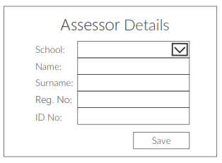

### UC 2.1

|  |  |  |
| --- | --- | --- |
| Use Case ID: | UC 2.1 | |
| Use Case: | Secure Log in to TCA mobile application (FaceBook/Google) | |
| Notes: | User must be able to securely login on the TCA application | |
| Type: | Basic Path |  |
| Scenario: | Basic Path |  |
|  | Step | Action |
|  | 1 | User enters Username and Password |
|  | 4 | User clicks the submit button |
|  | 5 | System displays pop up ,alerting the user on successful login |
| Type: | Alternate | |
| Scenario: | User enters incorrect information | |
|  | Step |  |
|  | 1 | System displays alerts of null/invalid data entered |

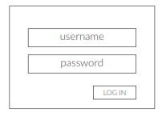

### UC 2.2

|  |  |  |
| --- | --- | --- |
| Use Case ID: | UC 2.2 | |
| Use Case: | Assessor needs to create Category (with Questionnaire as next level) | |
| Notes: | A link to the Category/Questionnaire capture screens is provided on the Landing Page | |
| Type: | Basic Path |  |
| Scenario: | Basic Path |  |
|  | Step | Action |
|  | 1 | Assessor either creates or edits new Category |
|  | 2 | Completes/Edits Metadata (Type with Question with Weighting) |
|  | 3 | Assessor clicks the save button |
|  | 4 | System displays pop up ,alerting the user on successful saving of Metadata |
| Type: | Alternate | |
| Scenario: | User enters incorrect information | |
|  | Step |  |
|  | 1 | System displays alerts of null/invalid data entered |

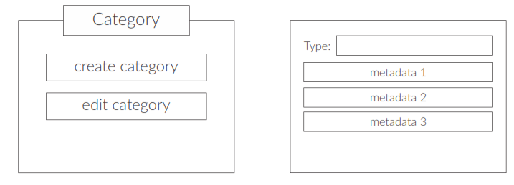

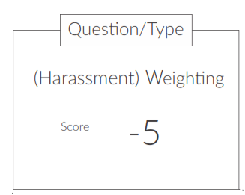

### UC 2.3

|  |  |  |
| --- | --- | --- |
| Use Case ID: | UC 2.3 | |
| Use Case: | Talent Credit Assessments completed against learner based on Category | |
| Notes: | Category determines the type of TCA and loads applicable Metadata required | |
| Type: | Basic Path |  |
| Scenario: | Basic Path |  |
|  | Step | Action |
|  | 1 | Assessor chooses learner which loads the applicable TCA |
|  | 2 | Assessor completes the TCA as accurate and objective as possible |
|  | 3 | Assessor clicks the save button |
|  | 4 | System displays pop up ,alerting the user on successful saving of TCA |
| Type: | Alternate | |
| Scenario: | User enters incorrect information | |
|  | Step |  |
|  | 1 | System displays alerts of null/invalid data entered |

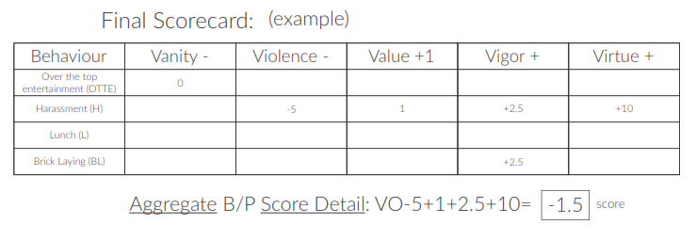

### UC 2.4

|  |  |  |
| --- | --- | --- |
| Use Case ID: | UC 2.4 | |
| Use Case: | Save and Persist TCA Information | |
| Notes: | TCA Assessor should be able to save the TCA to a centralised Data repository (Cloud) – for reporting | |
| Type: | Basic Path |  |
| Scenario: | Basic Path |  |
|  | Step | Action |
|  | 2 | TCA saved to centralised repository (Cloud) |

### UC 2.5

|  |  |  |
| --- | --- | --- |
| Use Case ID: | UC 1.5 | |
| Use Case: | TCA Report against Learner | |
| Notes: | Basic repost showing real time assessment on 5 V TCA chart | |
| Type: | Basic Path |  |
| Scenario: | Basic Path |  |
|  | Step | Action |
|  | 1 | Assessor can view Report |



# Non-Functional Requirements

The non-functional requirement elaborates a performance characteristic of the system.

This section focuses on the quality and qualitative aspects of the proposed solution.

In terms of authentication, the solution must comply with the TCR Policy. This includes:

* Only authenticated users allowed access;
* Login and password for super-users (administrative / development type users) – complying with the TCR standard;
* Passwords must not be displayed in a readable format on any application screen;
* Passwords may not be captured in audit logs;
* It must not be possible for a user to view data not pertaining to his operation.

## Usability

* The application will only be available in South African English;
* Minimal training must be required for use and navigation of the application.

## Reliability and Performance

* The online application must launch within 10 seconds;
* The application must visibly respond within 10 seconds on any action;
* The application must at least be available during office hours;
* If any back-end data becomes unavailable, the application must display a user-friendly message referring users back to the process;
* The solution must be able to respond to at least 80 concurrent users at a single time.

## Support and Maintenance

* The solution will be supported and maintained by TCR nominated employees / interns

## Capacity

* The solution must be able to store records for 2 years.

## Exclusions

* Integration to all systems not specified in this document.

|  |
| --- |
| **MVP Approval and Scope Sign Off** |

**© Copyright 2015 CodeRoom (Pty) Ltd. All rights reserved**

The copyrighted products, product concepts, designs and design methods contained or described in this document are confidential. This work, either in whole or in part, may not be copied, reproduced or disclosed to others or used for purposes other than that for which it is supplied, without the prior written consent of CodeRoom (Pty) Ltd, or if any part hereof is furnished by virtue of a contract with a third party, as expressly authorised under that contract. Microsoft Azure, Windows, SQL Server and .Net are registered trademarks of Microsoft Corporation

This is to certify that the Scope as pertained is accurate, as expected by the MVP Development criteria as set out by BizSpark in line with the expectation of the Stakeholders. The MVP Scope FRS (Functional Requirement Specification) has been delivered to the full satisfaction within scope of the MVP of the undersigned entities

|  |  |
| --- | --- |
| **For CodeRoom** | |
| Name: | Willie Burger |
| Position: | Software Solution Architect |
| Signature: |  |
| Date |  |
| **For BizSpark Member (AftaScool)** | |
| Name: |  |
| Position: |  |
| Signature: |  |
| Date: |  |
| **BizSpark Portfolio Manager** | |
| Name: |  |
| Signature: |  |
| Date: |  |